November 26, 2013

Rana Florida
CEO, The Creative Class Group & Author, Upgrade

Creative Entertaining: Gobble Gobble
Posted: 11/26/2013 8:48 am

Design, Thanksgiving, Video, christmas 2013, Creative Entertaining, Decor And Home Style, Dinner, Entertaining, Holidays, Holidays 2013, Style, HuffPost Home News

The traditional of Thanksgiving dinner has been celebrated since 1863. The annual feast may be fun for the guests, who get to kick back and watch the game on TV, but for the host who is preparing the turkey, the stuffing, and all the fixings, the day can seem like an endless chore. But even though the idea of planning, designing, buying, cooking, and serving may seem overwhelming, it doesn't have to be.
You don't need a florist or a party planner to make a memorable Thanksgiving. With a little creativity and imagination you can wow your guests without spending too much time or money. Here are some easy tips:

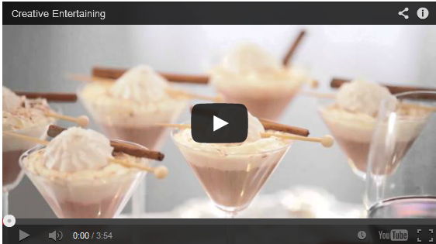
• Low ambient lighting and candles instantly transform any space. Hollow out pumpkins, squashes and other gourds and use them to hold candles, flowers and even ice.
• Interesting leaves can be even more striking than blooms, and they're almost always less expensive. Arrange branches and stones from your backyard into modern, organic vignettes.
• Use the color scheme of the season to customize everything from the table setup to the cocktails, linens and flowers. Incorporate a range shades and textures, from pale to dark.
• The gleam of gold, silver, copper, or bronze makes any event sparkle. Go ahead and mix metals if you like. Entertaining is about adding your own personal touches, so don't be afraid to display some uniqueness.
• Use syrups, spices, edible flowers, fruit and other seasonal ingredients to create festal cocktails. And don't forget about Mocktails for the kids. Serve them in a fun container with creative straws and garnish them with fruit.
• Setting up a dessert table allows for additional visual interest. There's no need to spend the time baking when so many specialty shops offer artistically-designed delectables. Almost anything can be customized to your theme, from cupcakes to lollipops to cookies.
Most important of all -- don't forget to join in the fun yourself. Holidays are a special time. Try to make this Thanksgiving memorable for everyone, including yourself.

Follow Rana Florida on Twitter: www.twitter.com/ranaflorida

